FACILITY CONTACT CIHI ERRORS

C1289
A contact information record for this facility (AA6) for this fiscal year (Z4) must exist before resident records can be submitted.

C1384
At least one internal or external data submission contact must receive auto-notifications for submission
reports (Z24 or Z34 or Z44 or Z54 =1).

A0032
Minimum requirement for the ‘Administrator’, ‘RAI 1’ and ‘Internal Data Submission Contact 1’ being completed and having the ‘Auto Notify’ value set to ‘Yes’ has not been met. Correct the CI (Contact Information) record and submit it to CIHI

Solution:

Login to the MED e-CARE system and navigate to “Settings”, “Facility tab”, “Organization/General Information”

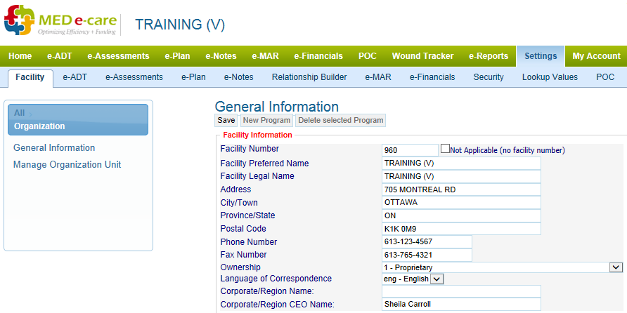

Click on the “Long Term Care” on the right hand side of the screen. For Complex Care hospitals this will say “Complex Care”
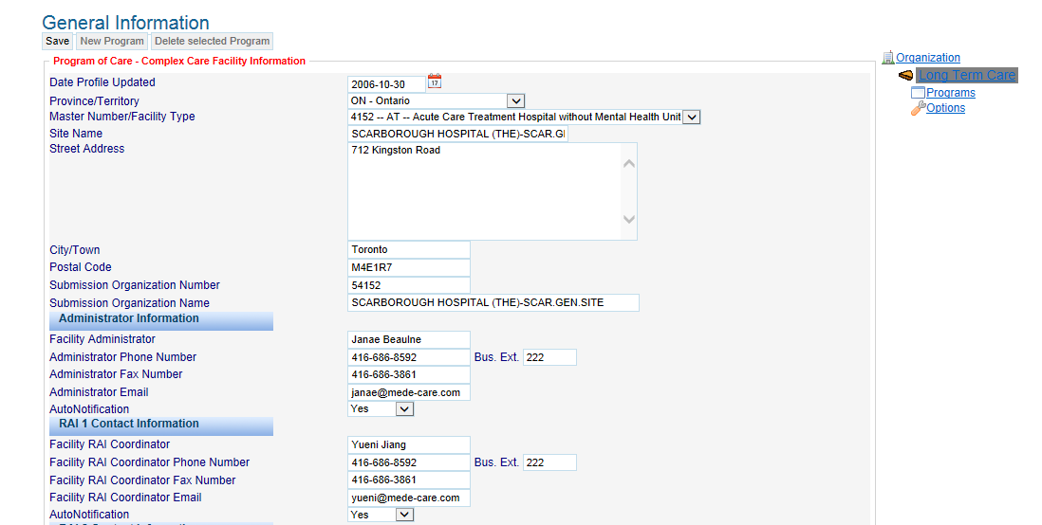
Review the information and ensure that it is correct.
For CIHI ERROR 1384 and A0032 review the options for Administrator Information and RAI Contact information and ensure they are populated with the appropriate information and Autonotification is set to “YES” on at least one record
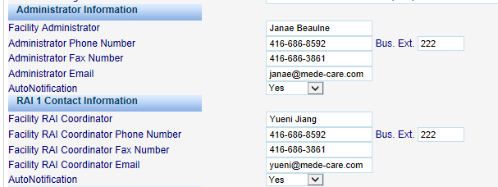

Save the changes before you exit and resubmit your Facility Information file. (Please see Facility Information Guide for step by step instructions).
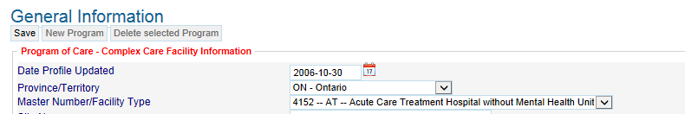

C1305, C1308, C1311 and C1317

Other disease diagnosis code (I3a) must match a valid ICD 10 code. The decimal is implied and not submitted.

Solution:

The ICD10 code(s) used is incorrect or out of date and must be corrected. Use the Global Diagnosis Search tool in section I3 to find the correct diagnosis code(s).
Before correcting ANY assessment that has been rejected with a coding error, please manage your submission file and mark the assessment as rejected (Please see Managing a Submission guide for step by step instructions).

Login to the MED e-CARE system and navigate to “e-Assessments, Assessment Tools, CCRS”.
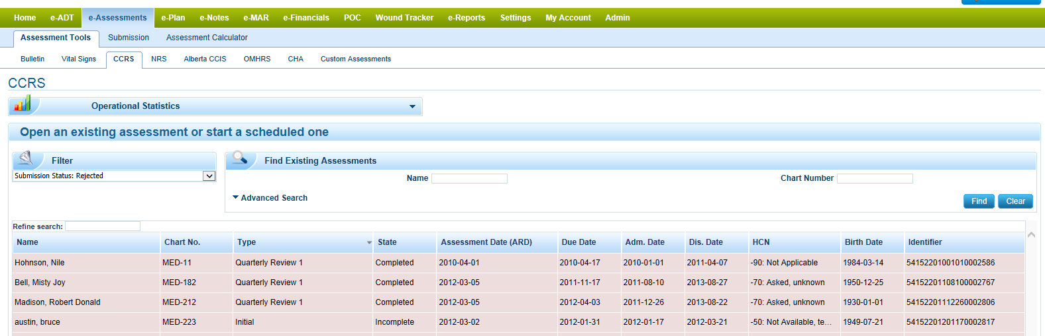
On the top left side of your screen, select the filter option “Submission Status: Rejected”
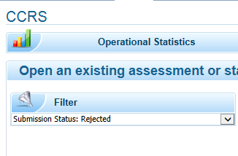

Search for select the assessment the requires correcting.
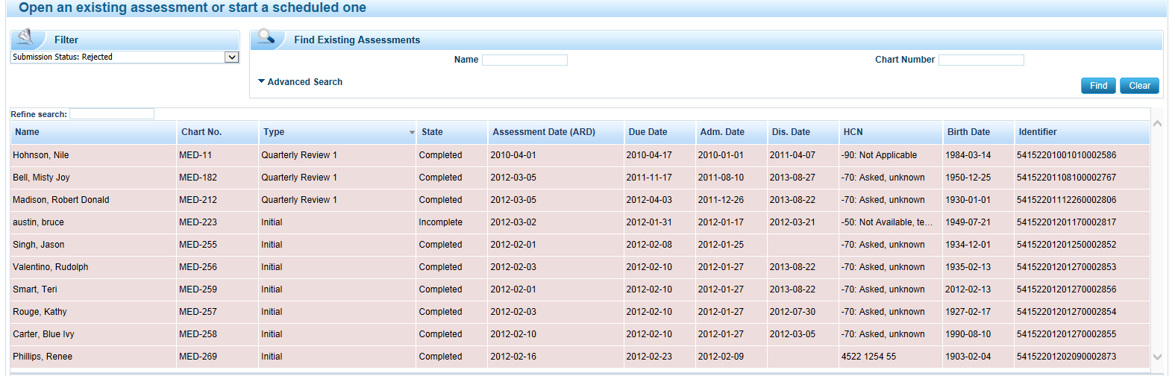

Navigate to the Signature Section of the Assessment and “unsign” the assessment
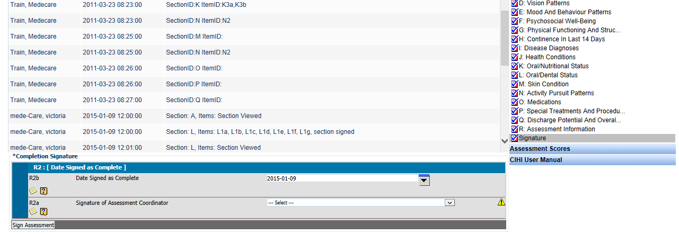

Navigate to Section I, Disease Diagnosis and remove the check from “Mark Section as Complete”
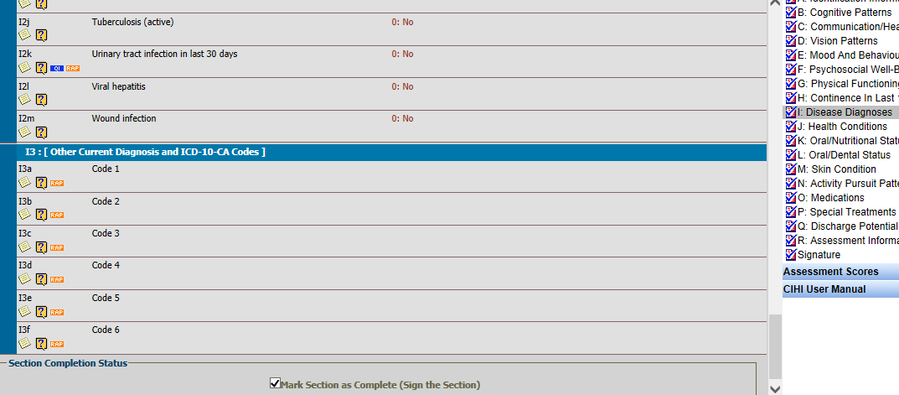

Use the global ICD10 code search option and select the applicable ICD10 codes and mark the section as complete.

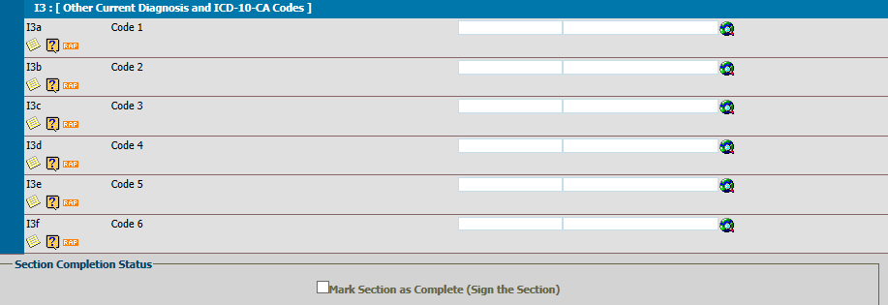
Navigate back to the “Signature Section” and re-sign the assessment. It will be ready for resubmission in the Submission Option of the system.

C1053
If the health card number is issued by Ontario (AA5b = ON) the health card number (AA5a) must be 0, or a 10 digit number with optional 2 alphabet letter version code( 1st digit number cannot be 0; 10 digit number cannot be 9999999999; 10 digit number must be validated using the MOD 10 algorithm)

C1275
Resident from the same facility (AA6) with the same health record number (A6a) already exists in the CIHI system with a different health card number (AA5a). Please check all personal identifiers. Health care number of 0 or 1 is excluded from this comparison
Correct the health card number. It must be ten (10) numeric characters in length and may include an optional two (2) character alpha version code (e.g. 123456790AB).

C1276
Resident from the same facility (AA6) with the same health card number (AA5a) already exists in the CIHI system with a different health record number (A6a). Please check all personal identifiers. Health card number of 0 or 1 is excluded from the comparison.
Assessment rejected because it is using the same health card number as another resident. Ensure that the correct HCN is being used or contact CIHI for further assistance.

Solution:
Using the same steps as above in the ICD10 Code error correction, ensure you have marked your assessment as rejected, navigate to and open the assessment that requires correcting, un-sign and the assessment and navigate to “Section A – Identification Information” and remove the check from “Mark as Complete”.
Navigate to element AA5 and ensure the correct Health Card number is entered. If you continue to have problems please contact CIHI directly.
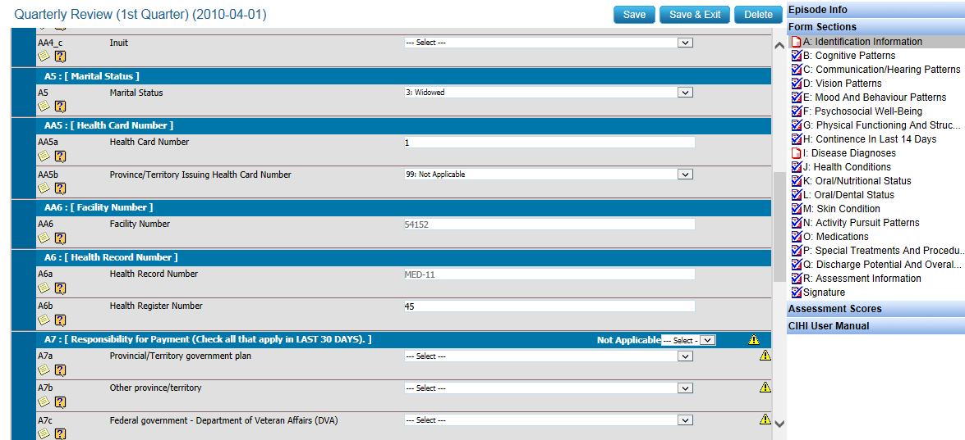

C1333

A "new' resident record must have a combination of facility identifier (AA6), record type (Y2) and unique record ID (Y1) that does not already exist in the CIHI system.

Solution:
This assessment has been previously submitted and accepted by CIHI.
If it was resubmitted in error, ignore the rejection.
If not, mark assessment as ‘Accepted’ in the submission history and then un-sign the assessment and then re-sign the Assessment. This will flag the assessment as a ‘Correction’ and it can then be included with the submission.
If you need assistance on how to manage your submission files please see Managing a Submission guide for step by step instructions.

C1293 and C1330
Admission Re-Entry date (AB1), unique registration identifier (AA1) and health record number (A6a) must match an existing resident's admission/Re-Entry in the CIHI system.

Solution:
CIHI does not have the most recent Re-Entry/Admission assessment in their Database.
Verify that all admission, discharge and re-entry assessments for the resident have been submitted and accepted by logging onto the CIHI website and running a VAR (Verification Audit Report). If you need assistance running a VAR report, please see our VAR report video tutorial for step by step instructions.
The assessment dates in the VAR much match with what appears in the MED e-Care software.
Submit any missing assessments before resubmitting the rejected record.

With the VAR report in hand, open an assessment the applicable resident. Down the left hand side of the screen, it will list all the assessments created in the system for that resident in chronological order. Compare the list to the data for that resident on the VAR report to determine which ones are missing on the VAR. Resubmit any missing prior assessments before resubmitting your rejection.
With the VAR report in hand, open an assessment the applicable resident. Down the left hand side of the screen, it will list all the assessments created in the system for that resident in chronological order. Compare the list to the data for that resident on the VAR report to determine which ones are missing on the VAR. Resubmit any missing prior assessments before resubmitting your rejection.

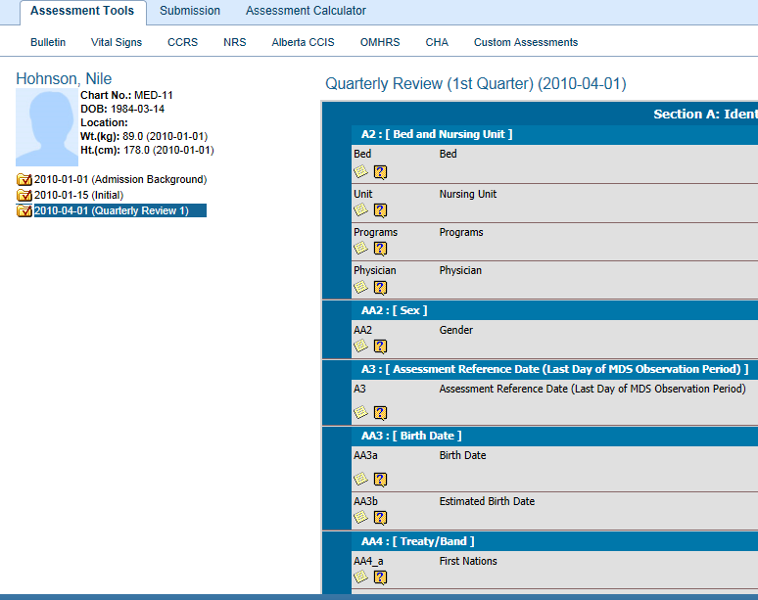

C1338
A resident previous admission/re-entry must have an associated discharge record (DC) before a new admission/re-entry (AD) record can be submitted.

Solution:
Previous discharge has not been accepted by CIHI. A discharge assessment must always be submitted and accepted before a new Admission or Re-Entry assessment can be submitted. Using the same steps as above check the VAR report and compare to what is in the system for that resident to determine which assessments need to be submitted before resubmitting your rejected assessment.

C1339
If the resident was discharged and then returns to the facility an admission record (AA7 = 1) is expected if it has been more than 14 days from the previous admission and there is no assessment with the same URI in the system OR it has been more than 92 days from the last assessment that exists in the CIHI system.

Solution:
Could be one of two things:
1. Resident was discharged and missed their next scheduled assessment. Upon return a re-entry was done instead of an admission.
Please delete the Re-Entry in e-ADT and process as an Admission record in e-ADT. Navigate to e-Assessments and complete the Admission Background and Initial Assessment.
or
2. A previous assessment has been rejected and needs to be accepted before this assessment can be submitted.
Run a VAR to verify assessment precise sequencing and submission status. Ensure that the previous assessment is submitted and accepted.

C1345
Element effective date (Z12) must be after the admission/re-entry date (AB1)

Solution:
This is an update record rejection and indicates that the ARD value on the update record is earlier than the ARD value on the admission that is being updated. The date of your “Update record must be AFTER the date of Admission.
Ensure that you have marked your “Update Record” as rejected. Navigate to the e-Assessments, search and open the applicable “Update Record” for the resident. Un-sign the assessment and navigate to “Section A Identification Information” and remove the check from “Mark the assessment as complete”.
Change the date to reflect a date AFTER the admission date for that resident in element Z12 “Element effective date”
Mark the section as complete and re-sign the assessment. It will ready for submission in the submission option of the system.
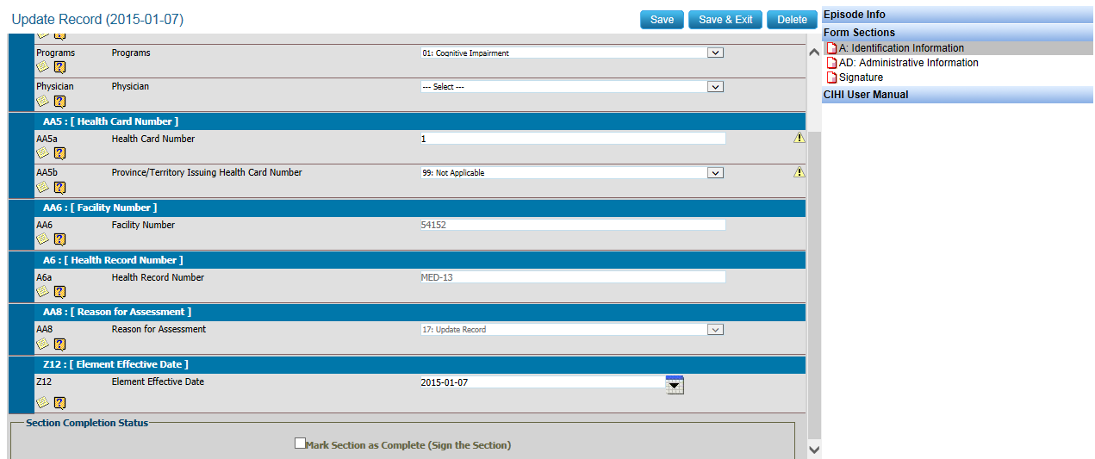

C1334
A "correction" resident record must have a combination of facility identifier (AA6), record type (Y2) and unique record ID (Y1) that already exists in the CIHI system.

Solution:
The Assessment was 'corrected' before being marked as 'Rejected'. The record must be submitted as a 'New' record before it can be accepted by CIHI. Any assessment that has been rejected from CIHI must be marked as 'Rejected' in the software before making any changes to the assessment.
If require please refer to our Managing a Submission guide for step by step instructions on how to properly mark assessments as accepted and rejected.

