How to set the Widget Settings in Patient Profile?

- Go to any Resident’s Patient Profile using the blue ‘Search Client’ button in the top right corner of any module.

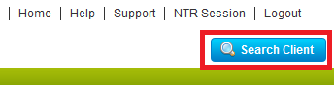
- Click on the ‘Widget Settings’ link in the patient profile screen.

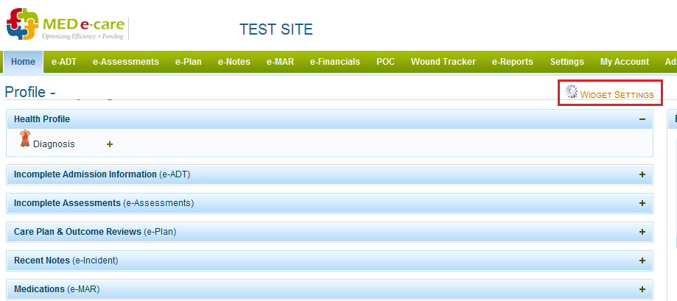

- From here you can edit what you want to see from the Patient Profile screen.

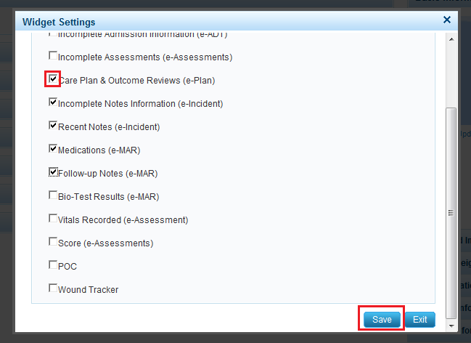

- Select the widgets that are to be shown in the Patient Profile Screen by Clicking the Check Boxes.
- Click on Save button to save the Widget Settings

