**How to Create an Unplanned Discharge without a**

**Completed Assessment In NRS**

1. **Go to E-Assessments ---> NRS.**

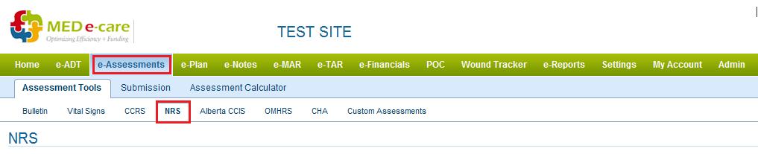

1. **Scroll to the Bottom and Click “ Start an Unscheduled Assesment ”.**

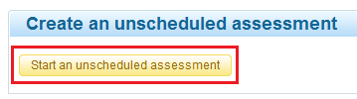

1. **Select the Resident from List.**
2. **Select Assessment Option as “Admission”.**

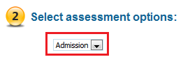

1. **Click Create the Assessment.**

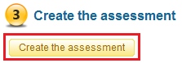

1. **Enter ARD and Select “Un-planned Discharge without Assesment” from Admission Class drop down menu.**

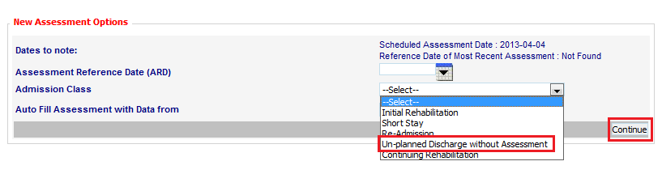

1. **Click Continue and complete the assessment.**